**Program main module analyzes**

MAIN PURPOSE & DESCRIPTION:

The main purpose of the module is to view the Google music account user management. The user runs the program and has an opportunity to choose the options he`d like to see. Whether he wants to see music playlist and see what user likes to listen to, or to see the music he most likes by seeing the rates he`d given, etc.

When user enters to get data, firstly he has to sign up, to have access to an account. Then he uses some of the options he`d like to see and that`s all, he gets the results. After that he can continue using features and get other information or quit.

INPUT & OUTPUT:

There are 4 inputs: login, password, option you`d like to choose and than program asks whether you want to continue or to quit.

Options:

* Song library
* User genres
* User search history
* User`s promoted songs
* User stations
* Registered devices

Output: 1d graph with lists of information from users account.

STRUCTURE:

* **Main.py:**
  + **ask_for_credentials()**
  + **demonstrate()**

Imports: **class_atd** with class which makes Arrays and also imports ***Mobileclient*** (Google Music library with data).

Functions:

* ask_for_credentials() – signing up to the account.
* demonstrate() – displays the interface of main module.

Classes:

* class_adt, which represents all data in array.
* array_adt, with classes. Represented in doc file(Abstract Data Types).

TEST CASES:

Example of using program:

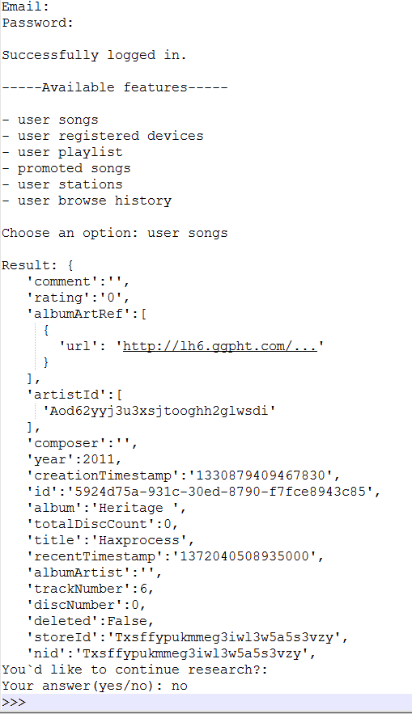

Other test cases:

* If you will enter password or login incorrect 3 times:

AcessError: Sorry,those credentials weren`t accepted.

* If you enter unavailable feature:

AssertationError: Sorry, there is no such option!